Tailored Application Access for Enhanced User Experience

**TEAM MEMBERS:**

G. Jaya bharathi - 9BC8ED109DAD7DDBC8949D5138138ACC

D. Shalini - 593EE86F607C7C593764CEC9140475BB

C. Sathya - 21C7E560C8B3617B4DF493881420E72D

M. Monica Hirin - C475574DAF7EF3AACD84B2D043E12DD1

# Project Overview

This project, *Tailored Application Access for Enhanced User Experience*, is designed to address the challenge of optimizing user interaction with digital platforms by providing personalized and seamless access. The goal is to deliver a comprehensive solution by leveraging advanced user-centric design principles, adaptive technologies, and intelligent access control mechanisms. Through this project, we aim to enhance user experience, improve operational efficiency, and ensure robust data security. This initiative aligns with the long-term objectives of empowering users and streamlining application interactions within Service now.

# Objectives

**Business Goals:**

1. Make it easier for users to access applications.
2. Save time and reduce effort for users and support teams.
3. Strengthen security while keeping things simple for users.

**Specific Outcomes:**

1. Build a system that adjusts access based on user needs.
2. Ensure the new system works with all current tools.
3. Add secure login options like fingerprint or OTP.
4. Collect user feedback to improve the system over time.
5. Provide easy-to-follow guides for users.
6. Create a tool to track how well the system is working.

# Key features and Concepts Utilized

1. Personalized access allows users to see only what they need based on their roles and preferences.

2. Secure login options, such as fingerprints, OTPs, or passwords, ensure user safety.

3. The system integrates easily with existing apps and platforms for seamless adoption.

4. A simple, user-friendly design makes navigation intuitive and efficient.

5. Performance tracking tools help monitor how well the system is working.

6. Strong security features, including encryption and regular checks, protect user data.

7. The system is adaptable to changing needs and user feedback.

8. It is designed to be accessible and inclusive for all users.

# 4. Detailed steps to solution Design

**Pre-Requisites:-**

1. Knowledge on Service Now Administration.
2. Knowledge on Applications & Modules.

**Skills used to solve the problem statement:-**

1. Service Now Administration.

**Activity 1: Create a Table**

I have accessed the ServiceNow Developer Instance and navigated to the "Tables" section under System Definitionmand I created a new table named "Service Request" with two columns: "Name" and "Issue" of type String, submitted the new table.

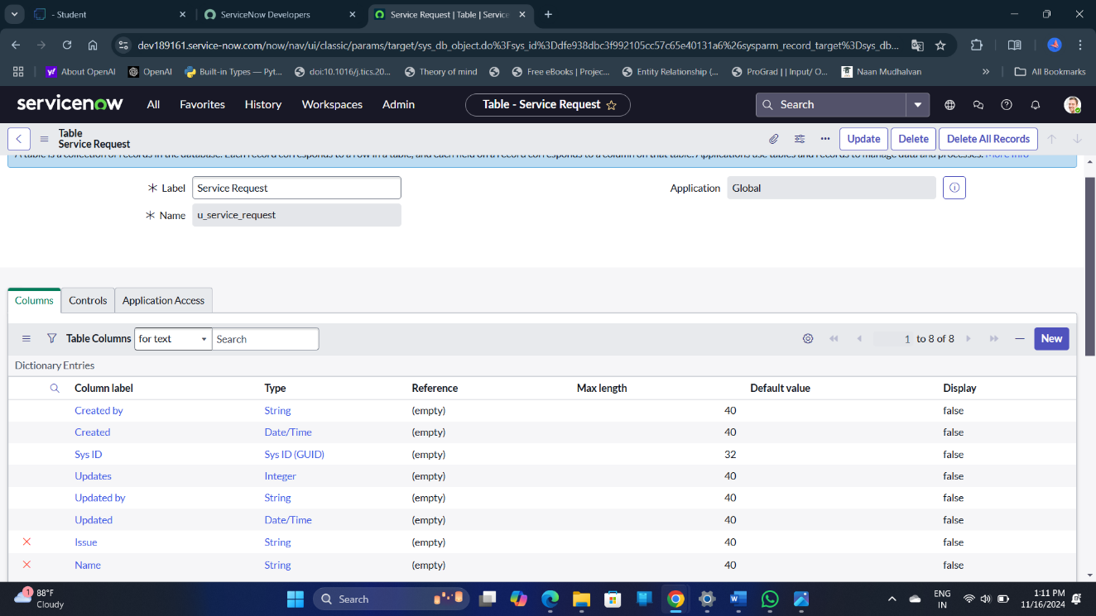

**Activity 2: Create Users**

I have navigated to the "Users" section under System Security and created a new user & filled in the necessary user details and submitted the form.

**Activity 3: Create Groups**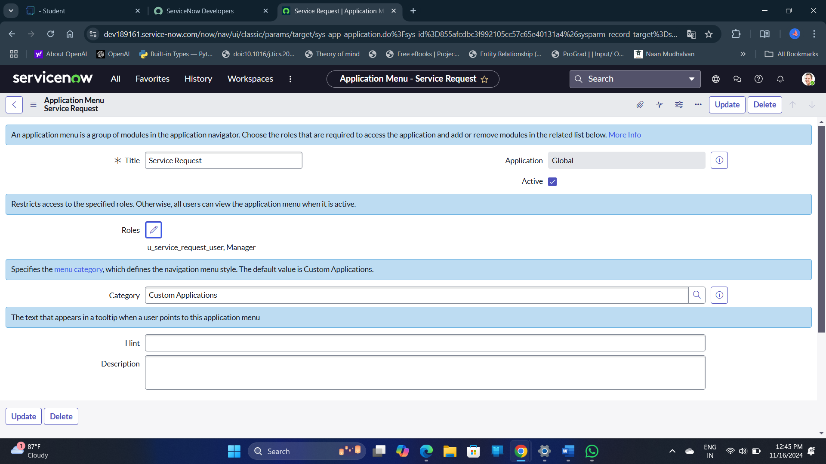 I have accessed the "Groups" section under System Security and created a new group & added a user (Jai Prakash) to the Manager group and saved the changes.

**Activity 4: Create Roles**

I created a new role under the "Roles" section of System Security.

After creating the role, I assigned it to a user (Jai Prakash) by adding the role to their profile.

**Activity 5: Create Modules**

I accessed the "Application Menus" section and selected the Service Request menu. I created two new modules titled "Create New" and "All" and assigned the appropriate roles for visibility.

I saved the modules and ensured the changes were applied.

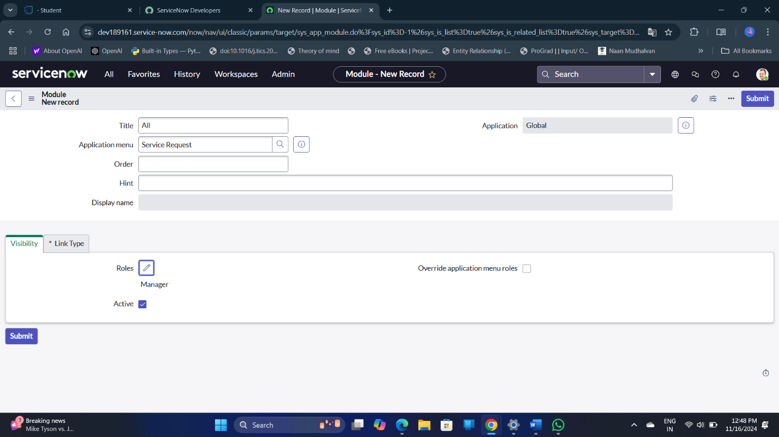

**5.Testing and Validation**

1. I navigated to the Profile section and selected "Impersonate User."
2. I chose the user I had created and clicked on "Impersonate User."
3. I went to "All" and searched for "Service Request."
4. I accessed the "Service Request" application and confirmed that the modules "Create New" and "All" were available. A computer screen with a computer screen and a computer screen

   Description automatically generated with medium confidence

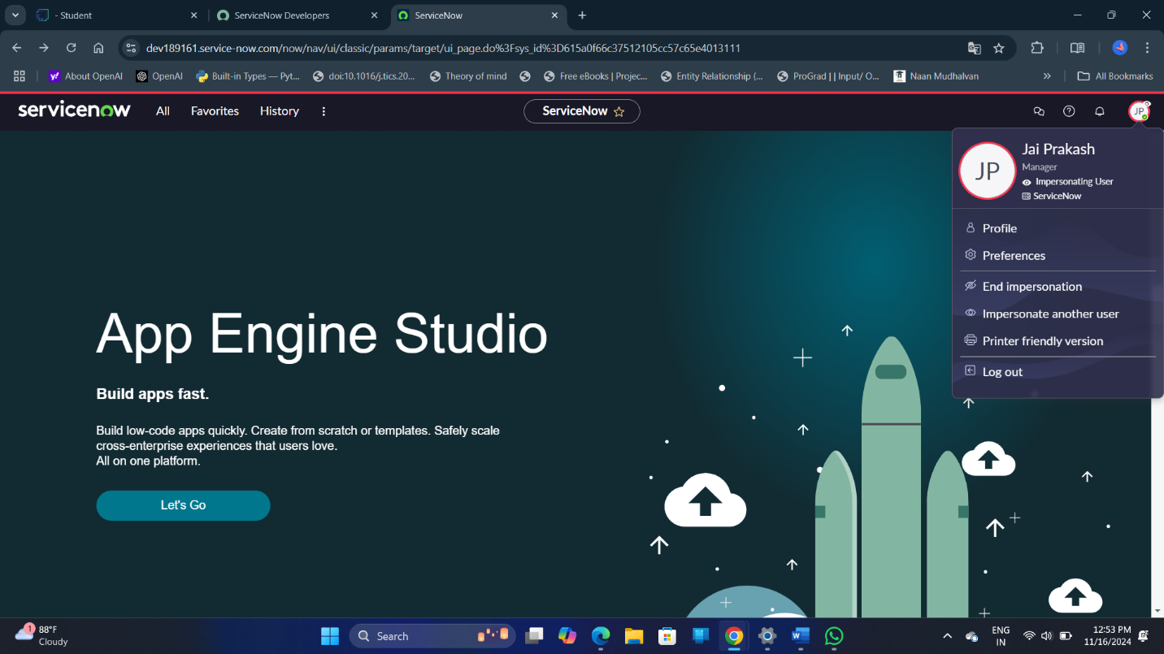

**6.Key Scenarios Addressed by ServiceNow in the Implementation Project**

GlobalTech Solutions was facing challenges with their internal ServiceNow instance. Their employees from various departments needed specific applications and modules that were only relevant to their roles. However, the existing setup in ServiceNow provided a generic view to all users, leading to confusion and inefficiency.

**7.Conclusion**

1. Successfully created a new table ("Service Request") with relevant columns (Name and Issue) in ServiceNow.
2. Created new users and assigned roles to them for proper access and functionality.
3. Established user groups and added members (e.g., Jai Prakash) to the appropriate groups.
4. Defined new roles and assigned them to specific users to manage access control.
5. Designed and implemented modules ("Create New" and "All") under the Service Request application, ensuring role-based visibility.
6. Used the impersonation feature to verify the user access and ensure the availability of modules in the Service Request application.